Winterton Community Academy

Newport Drive, Winterton, Scunthorpe, North Lincolnshire, DN15 9QD

Telephone: (01724) 732777

email: reception@wintertonca.com

Headteacher – Mr K Rowlands

Ref: GCSE info/ RFE/ AW

27th June 2025

Dear Students,

**GCSE Results Day – Thursday 21st August at 9:00 AM**

We hope you are enjoying your summer break and taking some well-deserved rest after all your hard work during the exam season. Of course, there is the prom to still look forward to!

We are writing to inform you about the arrangements for collecting your GCSE results. Your results will be available for collection on **Thursday 21st August at 9:00 AM** in the school hall.

Please arrive promptly and enter through the main entrance in reception. If you are unable to collect your results in person, you may:

* Nominate someone to collect them on your behalf. They must bring a signed letter of authorisation from you and a form of ID.
* Request your results to be sent via post or email. Please contact the school exams office in advance to arrange this, sending a communication to Mrs Walker.

Email: walker.a@wintertonca.com

Staff will be available on the day to offer advice and guidance regarding next steps, including sixth form, college, apprenticeships, or other pathways.

We look forward to seeing you on the day and celebrating your achievements together.

Kind regards,

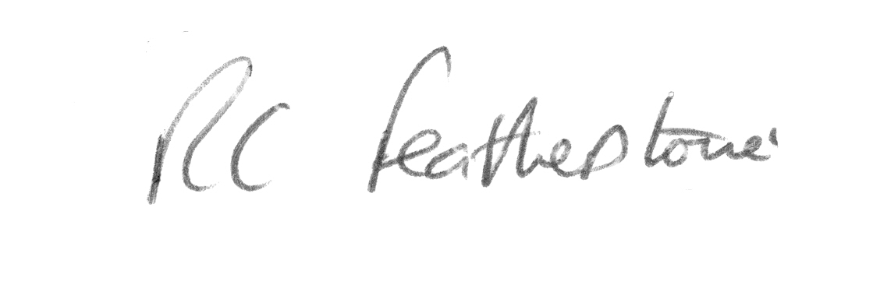

R.C Featherstone

Deputy Headteacher