Winterton Community Academy
Newport Drive, Winterton, Scunthorpe, North Lincolnshire, DN15 9QD
Telephone: (01724) 732777 Fax: (01724) 733051
email: reception@wintertoncommunityacademy.co.uk
Headteacher – Mr K Rowlands

Dear Parent/Guardian,

To ensure compliance with the Department for Educations’ Supporting pupils at school with medical conditions guidance the academy is improving its policies as regards to first aid and the giving of medication to pupils whilst at school.

For a member of staff to give any prescription or non-prescription medication written permission must be given to the academy by the parent/carer. In order to make this as simple as possible I have provided a tear off slip to complete and return to the academy by Friday 2nd December 2022. If written permission is not received by Friday 2nd December 2022, we may be unable to issue any medication after this date.

The academy can only accept prescribed medication if it is:

- In date
- Labelled and provided in the original container (as dispensed by the pharmacist)
- Include the pharmacist’s instructions for administration, dosage and storage

The only exception to the above conditions, is insulin, which still must be in date, but generally is provided inside a pen or a pump, rather than in its’ original container.

Non-prescribed medication, such as paracetamol etc, should be provided in the original box with the child’s name written clearly on the box along with instructions from a parent/carer on the dosage and regularity of dose. No medication will be given in an amount that exceeds the recommendations on the original packaging.

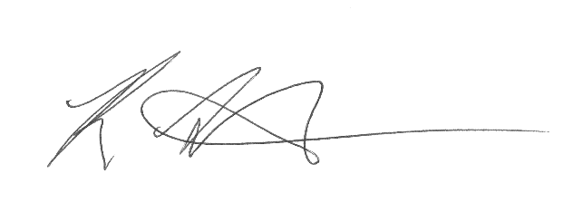
Kind regards,

Mr Rowlands
Headteacher

---------------------------------------------------------------------------------------------------------------------------

I …………………………………. (parent/carer) give my permission for my child
(insert parent name)

……………………… to be given ………………………………….. in line with the pharmacists
(insert child’s name) (insert name of medication)

Instructions on the original container.

Signed:……………………………………………….. Date: ……………………….
(parent/carer)

