Winterton Community Academy
Newport Drive, Winterton, Scunthorpe, North Lincolnshire, DN15 9QD
Telephone: (01724) 732777 Fax: (01724) 733051
email: reception@wintertoncommunityacademy.co.uk
Headteacher – Mr K Rowlands

Dear Parents and Carers,

In December, we conducted a highly detailed survey across our key stake-holder groups (Parents / Students / Staff) and I would like to thank those parents who took the time to share their views with us. This survey is an independent, professional survey and provides us with a highly detailed report including very specific areas of feedback in terms of what we are doing well as a school and what we can do better to improve.

This is the second time that we have completed this survey in the past three years, due to interruptions from COVID-19 and it will now take place annually to ensure that you have the opportunity to share your views and make a positive contribution to our continuous improvements as a school.
The overall executive summary will be made available in the near future on our website, however to summarise, the key headlines are as follows:

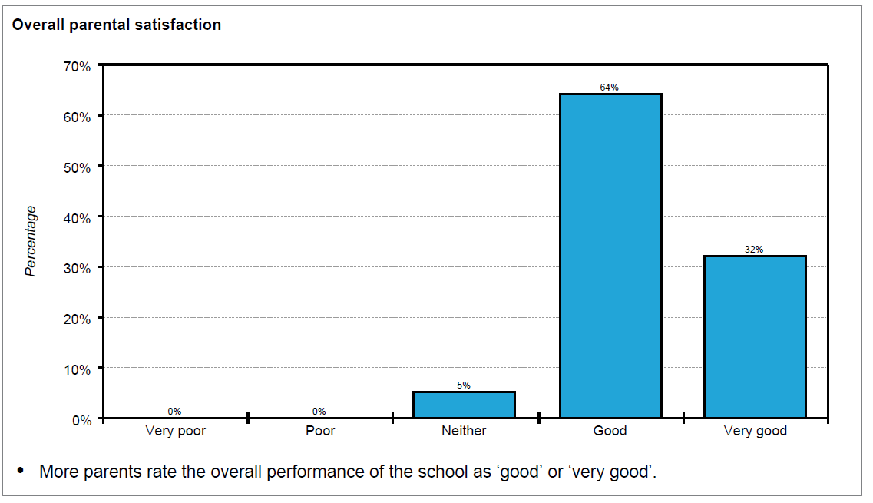
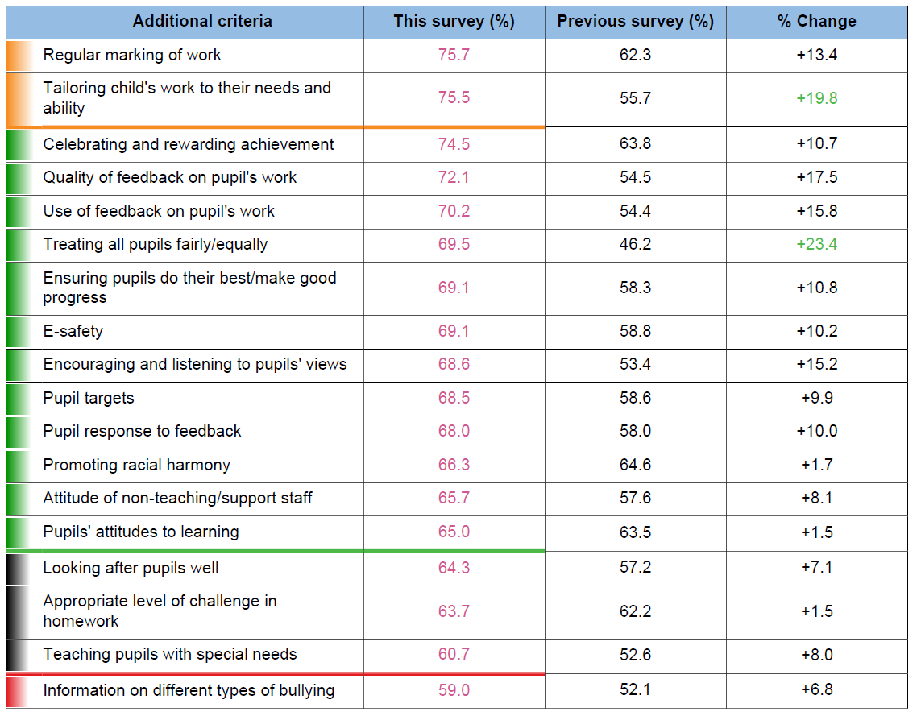

When compared to the previous survey of two years ago, there has been an improvement across all of the criteria with notable improvements detailed in the following areas:
- Tailoring child’s work to their needs and ability
- Treating all pupil’s fairly
- Encouraging and listening to pupils’ views
- Quality of feedback on pupil’s work
- Regular marking of work
The survey also highlights to us the priorities that you have identified as being of the most importance to you as parents and it is important that we understand this:
- Control of bullying
- School communication
- Choice of subjects
- Happiness of child
We recognise through this feedback that our areas for improvement from a parental perspective are seen as the following:
- Teaching pupils with special needs
- Appropriate level of challenge in homework
- Computer access
- Careers guidance and University expectations
This feedback is incredibly important to us as it enables us to establish our key priorities and ensure that we are meeting your expectations going forward.
We also recognise through our pupil responses, that their overall level of satisfaction has improved significantly since the last survey was completed.
Notably students have identified significant improvements across the following areas:
- School discipline
- School Communication
- Availability of resources
- Teaching quality
- Social health education
- Community spirit
- Exam results
We are very proud of the work that we are doing to ensure that Winterton Community Academy is a school that you can be proud of within the community however we still recognise that there are areas of improvement where we can better meet the needs of our pupils.
Our pupils highlighted the following areas as a priority for improvement:
- Treating all pupils fairly / equally
- Encouraging and listening to pupils’ views
- Computer access and overall facilities
Notably, pupils highlighted their happiness as the most important priority and that is certainly something that we should never lose sight of.
We will be sharing more information with our pupils in the coming weeks and engaging in further dialogue with them in regards to how we can best support them to be safe, happy and successful.

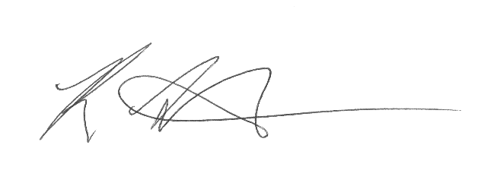
Kind regards,

Mr Rowlands

