Winterton Community Academy
Newport Drive, Winterton, Scunthorpe, North Lincolnshire, DN15 9QD
Telephone: (01724) 732777 Fax: (01724) 733051
email: reception@wintertoncommunityacademy.co.uk
Headteacher – Mr K Rowlands

Ref:staffassessment/2021-22/reportletter/kv

24th November2021

Year 8 Report: Autumn 2021

Dear Parent / Guardian,
Please find enclosed the Autumn 2021 academic report for your child. In order to use it to support your child, it is very important that you have a clear understanding of the context and the data used to inform it, as well as what the data means.

We have provided the attitude to learning (please see the additional information to understand the grading) and the half-termly assessment percentage scores for each subject, which are based on the acquisition of knowledge. This has informed discussions about how well your child is doing and their approach towards their learning. As staff, we have begun to analyse that data and are formulating how best to support your child moving forward.

If data is missing or incomplete in the report, this may be due to staff absence or the lack of an appropriate assessment. However, steps will be taken to ensure that assessments will be carried out as soon as possible to address the assessment gaps.
Please go to the following website to confirm receipt of the report, offer feedback and also request a further discussion with a member of staff if required.

https://forms.office.com/r/8u6p8CjBkb

A copy of this letter will be placed on the school website and sent out to parents via text message.

Yours sincerely,

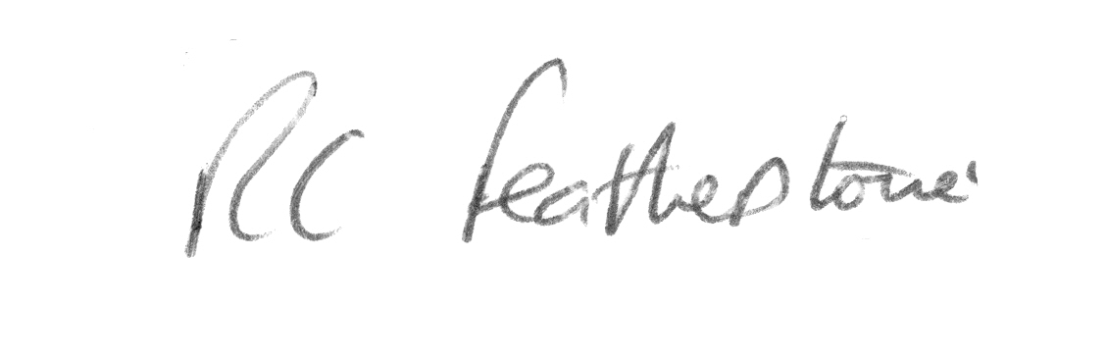
R.C Featherstone
Deputy Headteacher

