Winterton Community Academy
Newport Drive, Winterton, Scunthorpe, North Lincolnshire, DN15 9QD
Telephone: (01724) 732777 Fax: (01724) 733051
email: reception@wintertonca.com
Headteacher – Mr K Rowlands

Ref: kr/parlet/I:2021-22/kv 15th October 2021

Dear Parents and Carers,

As we approach the final week of this half-term, I am writing to say thank you for your support and patience through what continues to be a challenging period.

Based on our attendance in school, it looks like we have moved past the peak in terms of
positive Covid-19 infections, and our confirmed infections in school are currently 5% of the school population.

I anticipate that if this remains, then after half term we should be able to remove the necessity of working in bubbles and allow staff and students a return to some normality.

We will still maintain some contingencies and continue to encourage the precautions that are in place such as the wearing of face masks during transition, and in particular in crowded spaces, for example when they are using the school bus.

Over the past couple of weeks, we have experienced a higher degree of staff absence. This is for a number of reasons, some of which have been scheduled but also as a result of the impact of Covid-19, both directly and indirectly. I would like to say that our students have been magnificent in their response. Where we have needed to bring in additional supply teachers, our students have responded well, continued to complete their work and behave in line with the standards and expectations that we always require from them. I am really proud of them, and they are a credit to you.

I want to reassure you that this is very much a short-term concern caused by the current context and that as we look forward to the second half term, I am confident that normal service will resume.

You may be aware that Mr Lucas has taken the decision to resign his post as a teacher of science at the academy and he left last Friday to start his new career. Unfortunately, his new post did not afford him the opportunity to complete the term with us but we wish him well for the future. As a result, I am delighted to share with you that we have appointed a new teacher in Science. Mrs Allen is an experienced teacher having served locally for more than seven years and she will be a fantastic addition to the team when she starts in January.

The impact of Covid-19 throughout this term has been a challenge, but it has been fantastic to see our sports teams back in action over the past couple of weeks and it was nice to be able to speak to so many parents who came along to support them. We are committed to ensuring that our students have a broad range of experiences and activities available to them, and I would like to say thank you to all of our staff for everything they are doing to make this possible.

School currently feels like a really positive and happy place to be, and we are very much looking forward to the rest of the school year and the many positive opportunities that it will bring for our students.

Have a lovely weekend,

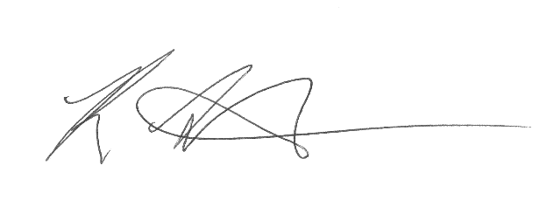
Kind regards,

Mr Rowlands

