Winterton Community Academy
Newport Drive, Winterton, Scunthorpe, North Lincolnshire, DN15 9QD
Telephone: (01724) 732777 Fax: (01724) 733051
email: reception@wintertoncommunityacademy.co.uk
Headteacher – Mr K Rowlands

Ref:Year10/2020-21/ Report letter/saj 20th April 2021

Dear Parent / Guardian,

Please find enclosed the latest academic report for your child. In order to use it to support your child, it is very important that you have a clear understanding of the context and the data used to inform it, as well as what the data means.

Up until now, we have reported the standard targets, attitude to learning (please see the additional information to understand the grading) and the half-termly assessment percentage scores for each subject, which are based on the acquisition of knowledge. This has informed discussions about how well your child is doing and their approach towards their learning.

From this point onwards, all pupils in Year 10 will also receive a ‘prediction’ grade. This is a professional prediction of what we could expect your child to attain using the knowledge of the individual, previous attainment data, attitude to learning data and also an awareness of the continued investment in the learning by all concerned. It should not be seen as a final grade. Nor should it be seen as a maximum grade, but as a guide to the outcomes at the end of Key Stage Four.
If data is missing or incomplete in the report, this may be due to staff absence or the lack of an appropriate assessment. However, steps will be taken to ensure that assessments will be carried out as soon as possible to address the assessment gaps.

Please go to the following website to confirm receipt of the report, offer feedback and also request a further discussion with a member of staff if required.
https://forms.office.com/Pages/ResponsePage.aspx?id=AQzOqzQMNUSeawXnZpQrg_aZRItg261Ipf10hu5Veb9UNjNKT1hKUTI5V0k4UjE1QjVBQzBOWURITy4u
A copy of this letter will be placed on the school website and also emailed to those who have provided an email address. In order to facilitate this in the future, it would be appreciated if you could provide us with an up-to-date email address if you have not already done so.

Yours sincerely,

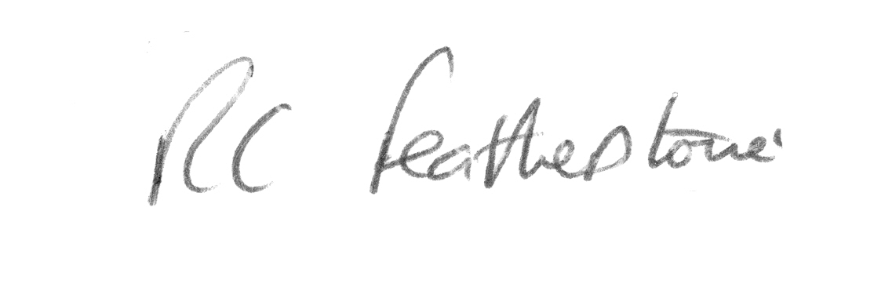

R.C Featherstone
Deputy Headteacher

