Winterton Community Academy
Newport Drive, Winterton, Scunthorpe, North Lincolnshire, DN15 9QD
Telephone: (01724) 732777 Fax: (01724) 733051
email: reception@wintertoncommunityacademy.co.uk
Headteacher – Mr K Rowlands

Dear Parent / Guardian, 6th October 2020

As we continue to enhance our curriculum within the school, with the aim of allowing all of our pupils to make at least expected progress, it is clearly apparent that literacy is of paramount significance. The ability to read with fluency and to have a wider range of vocabulary and understanding enables pupils to access the curriculum and to then be able to have clarity about what is being asked in the examinations.

In addition, the G.C.S.E. examinations taken at the end of Year 11 reward pupils for their literacy, allowing them to boost their marks and benefit from stronger literacy skills in subjects such as English and History.

Therefore, as part of the renewed Literacy Strategy, I have made available to you a list of suggested reading books for each academic year at school. All are age appropriate, but can offer varying degrees of challenge. Some of the books are available within school, whereas others are not, but may be so in the local library or elsewhere. The books identified are only a suggestion, and it may be that your son or daughter prefers to read different books. That is wonderful, and is still allowing them to benefit from reading. The key is to enjoy them and hopefully to feel more confident in their understanding of the characters, the story and the style of writing.

The reading lists can be found on the school website:
www.wintertonca.com/literacy

I would encourage you all to ask what books are being read and to also ask questions about the book. Being able to answer questions beyond simple sentences is hugely beneficial and means that it is easier to write and explain answers in the same way in lessons and examinations.
Even prior to the production of this letter, parents have asked if they could donate any books that are on the lists to the school. This is most certainly appreciated, as they can only increase the opportunities available to read.

Further information will be made available on the website in the near future, as we continue to give the best we can for all the pupils in the school.

Should you wish to discuss this further, then do please contact me at the school.
Yours sincerely,
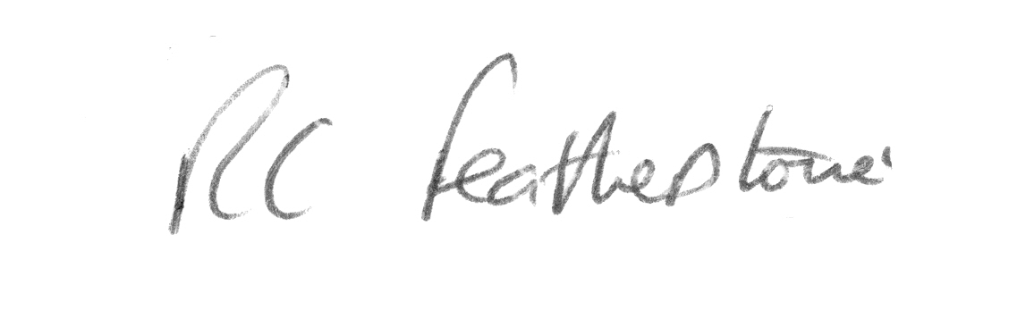
Mr R. Featherstone
Deputy Headteacher

