Winterton Community Academy
Newport Drive, Winterton, Scunthorpe, North Lincolnshire, DN15 9QD
Telephone: (01724) 732777 Fax: (01724) 733051
email: reception@wintertoncommunityacademy.co.uk
Headteacher – Mr K Rowlands

REF:doddle/parentletter2018/saj 25th September 2018

Dear Parent / Guardian,

As part of our ongoing actions to further improve the quality of our teaching and learning, assessment and availability of independent study, we have subscribed to an online learning and assessment platform, Doddle.

Doddle contains detailed curriculum checklists and targeting tools which support thorough assessment, clear reporting and effective intervention. It is also an online homework and revision resource that makes it easier for your son/daughter to understand and develop what they have been studying in class. Teachers can assign resources and tasks to complete. Or, Doddle can be used independently to revise and find extra help with other homework.

All of the staff have been introduced to Doddle and have begun to use it to assess work with even greater accuracy. The next step is to introduce it and how it can be used to all the pupils in the school. This will take place during the week commencing 24th September 2018 in assemblies.

In order to log in, the pupils will require a username and password. The details of how to log in are below:
- Go to www.doddlelearn.co.uk
- Click on ‘Login’ in the top corner
- Type in the name of the school. The name will appear from a list available.
- Your username is ‘forename surname year you began in Y7’ eg. OwenFarrell14 if he was in Y11
- The password is ‘Winterton.Pupil’. This will need to be changed when you log in to prevent others from accessing your account.
Once logged in, your son/daughter can then explore, check their ‘To do’ list, submit homework and use the resources for revision. For those pupils who are unable to access Doddle from home, we have provided the ‘Homework Hub’ on both a Tuesday and Thursday.

Should you wish to discuss this matter further, do please contact me at the school.
Yours sincerely,

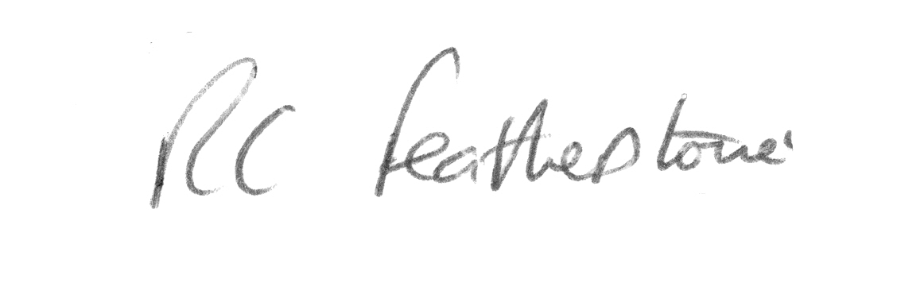
Mr. R. Featherstone
Deputy Headteacher

